

Pest Control Cedar City | Advice on how to prevent roaches in your home.
Read this Post
Vision Pest Solutions Cedar City | Pests such as roaches, ants, spiders, and rodents are a problem for many homeowners. They can cause damage to property and food supplies as well as spread diseases. But what you might not know is that there are things you can do to deter these pests from invading your home in the first place.
Here are a few suggestions on how to keep these pests out of your home:

Keep all food in airtight containers. This includes pet food and birdseed.
It is important to keep all food in airtight containers. This includes pet food and birdseed. Keeping your home free of pests will not only keep you from being bitten but will also save money on pest control services. Pests are attracted by the smell of human or animal smells, so be sure to wash your hands before eating or brewing coffee, have no dirty dishes in the sink when they can’t be washed right away, and don’t leave any garbage out for more than an hour after trash day.
Pests are most active at night when humans are sleeping, so sealing up any potential entry points during that time with steel wool can help reduce infestations. Make sure windowsills are clean and dry – bugs love moist, damp places. If you have a pet, check its food and water dishes frequently and empty them if needed. Keep your pets in at night when they cannot be supervised so pests won’t feed on them or their food.
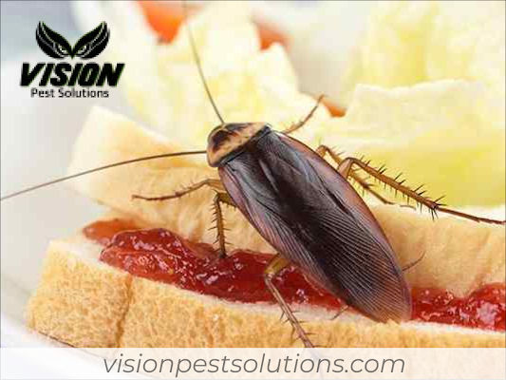

Store dry goods, such as cereal, pasta, and rice, in glass or metal containers with tightly fitted lids.
The best way to prevent roaches in your home is by reducing the food supply. Store dry goods, such as cereal, pasta, and rice, in glass or metal containers with tightly fitted lids. Make sure your kitchen counters are clean and free of crumbs. Rinse out all recyclable items that may have small amounts of food waste on them before putting them into the recycling bin. Inspect cardboard tubes, such as a paper towel or toilet paper rolls, for any signs of roach nests before discarding them in the garbage. Empty garbage cans regularly to prevent any roaches from nesting inside. Dump any standing water that you see in sinks, pails, or other containers, since this may also attract roaches. Mop floors and clean up spills immediately to eliminate food residues and moisture. Apply a thin layer of petroleum jelly around doorframes, windowsills, and utility pipes to reduce possible entry points for these pests.

Clean up spills immediately.
Spilled food should be picked up and placed into a container with a tight-fitting lid. Crumbs from toaster pastries or cookies should also be cleaned up immediately rather than allowing them to fall onto the countertop or floor where they can attract insects and rodents. Spilled liquids should also be cleaned up immediately, as they can damage appliances or form puddles that become home to insects and rodents.
All foods should be kept covered at all times; this reduces odor presence and helps prevent infestation by insects and rodents. Food containers should only be opened when necessary to reduce the risk of contamination from airborne particles. When cooking outdoors over a grill, it is important to cover the grill to contain the smell of cooking food and prevent it from attracting bugs or rodents.

Sweep floors often so crumbs do not have time to settle overnight where roaches can find them easily Pet food should never be left out overnight.
Roaches are often found in the home due to the habits of people living there. If you sweep your floors often, then crumbs will not have time to settle overnight where roaches can find them easily. Crumbs should be picked up by sweeping or vacuuming. Pet food should never be left out overnight; it is another source of food for roaches. If you have a problem with roaches, read the label of any pesticide you use at least twice to make sure you are using it correctly and safely. Follow all label directions exactly until you understand how to apply the product, when and where it can be used, whether pets and people must be gone from treated areas while it dries, what protective clothing may need to be worn during treatment, how long protective clothing needs to remain in place after application, and so on.
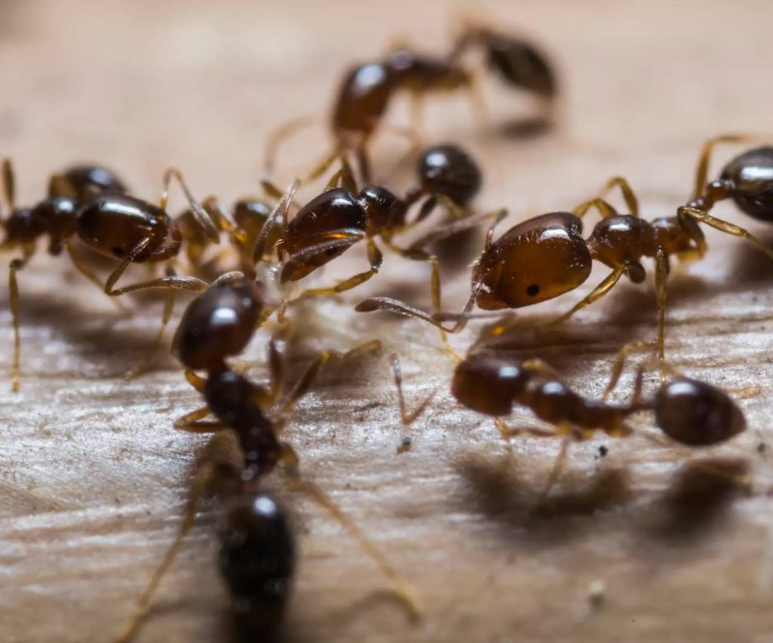

Keep your counters, cabinets, and floors clean and free of clutter.
Visit Our Website
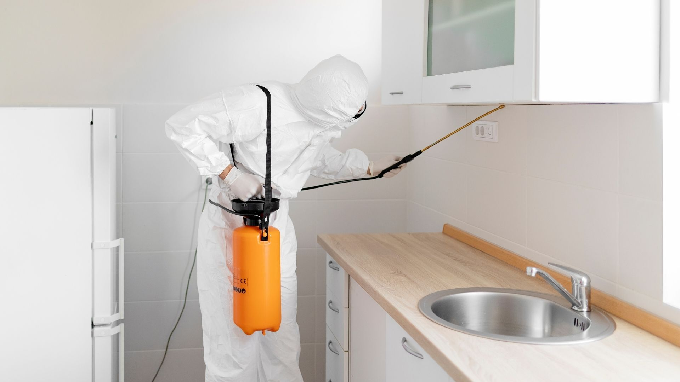
One of the easiest ways to keep roaches out of your home is to make them inaccessible. Keep all cabinets, counters, and areas under sinks clean and free of clutter. Roaches are unwelcome guests in homes where people leave food lying around or dishes in the sink for days at a time. Food scraps will attract them, so make sure you throw away any leftovers promptly – don’t let dirty dishes sit in your sink overnight! If you like to eat while watching TV or working on the computer, make sure that you take care of any mess immediately after eating since crumbs can also prove irresistible to these pests. You should also never leave open packs of food – especially pet food – lying around. Store what you’ve bought in airtight containers or Ziploc bags.
If you live in an apartment building, keep your eyes open for any cracks or gaps around the baseboards of your unit. These are their favorite entryways into your home and can also be used by other pests like mice and cockroaches. Make sure to fill up any holes with some steel wool to keep them out! You can do this when moving into a new place too – just check along with the floors under the wall-to-wall carpeting.

Repair any leaks in the kitchen or bathroom.
In an average year, the typical American home has over 10 different types of pests. These include cockroaches, termites, ants and rodents. They can be a real nuisance to homeowners as they contaminate food and spread disease. Repair any leaks or water damage in your kitchen or bathroom as soon as possible as this is where most roaches live. Another reason for roaches may be due to a lack of hygiene. Keep your kitchen clean and dry, store food in sealed containers, and don’t leave dirty dishes overnight.
Make sure your sink is never overloaded with dirty dishes as these are sources of water for roaches. Empty garbage cans regularly and make sure there is no trash nearby. Make sure all food is put away or stored in airtight plastic containers. Clean up any crumbs on the floor after eating meals as this can attract roaches. Don’t leave dirty dishes overnight as they become a source of water, allowing the roach to breed more rapidly. Use a cloth or paper towel that can be easily disposed of to wipe down surfaces where you prepare food as this will help remove any oils or food particles that roaches like to eat.

Make sure you have screens on windows and doors to keep out insects like spiders, bees, ants, centipedes, and other undesirable visitors.
Make sure you have screens on windows and doors to keep out those unwanted visitors. Then, if you do see one creep in the window or door cracks, there are some natural ways to get rid of them without having to resort to toxic chemicals that could harm your family or pets. For example: pour boiling water into a bowl and put it by an open window so that the steam will blow through the house; use bay leaves as a deterrent for ants; set up sticky traps around any areas where bugs might enter from outside; leave bowls of apple cider vinegar where there are spider webs or other evidence of bugs living.
Name: Vision Pest Solutions
Phone: (435) 421-1709
Address: 471 E 2015 N, Cedar City, UT 84721, United States
Email: visionpestut@gmail.com
Website: https://www.visionpestsolutions.com/

https://rank-fortress-digital-agency.github.io/visionpestsolution-01-22/
http://visionpestsolution-01-22.s3-website-us-east-1.amazonaws.com/
https://f004.backblazeb2.com/file/visionpestsolution-01-22/index.html
https://visionpestsolution-01-22.s3.us-west-004.backblazeb2.com/index.html
https://confident-boyd-9eca63.netlify.app/
https://icedrive.net/s/jFPAXZWR72gaQRW82AFCWiF6P6kD
https://u.pcloud.link/publink/show?code=kZP2kGXZbHaraifORwXoDz583DRNoRpHBkNX
https://visionpestsolution-01-22.oss-us-east-1.aliyuncs.com/Pest%20Control%20Cedar%20City%20_%20Advice%20on%20how%20to%20prevent%20roaches%20in%20your%20home.pdf

